Airfoil Performance Analysis Report:

**1. Introduction**

In this study, I evaluated the aerodynamic performance of three different airfoils at Reynolds numbers of 50000, 500000 and 200000 with a Mach number of 0. The simulations were conducted in XFOIL, and the results were analyzed using five standard aerodynamic plots. The goal was to identify the most suitable airfoil for a horizontal take-off and landing (HTOL) aircraft application, focusing on efficiency, stall characteristics, and low-drag cruise performance.

**The Explanation of the plots:**

**1) Drag Polar — Cd​ vs Cl**

**What it is:** drag coefficient plotted against lift coefficient for a Reynolds/Mach case (the polar).  
**Why it matters:** shows how much drag you pay for a given lift. The lower the Cd​ at your cruise Cl the better the cruise efficiency; the shape near high Cl shows how quickly drag rises approaching stall (important for take off /landing).

**2) Lift Curve — Cl​ vs α**

**What it is:** lift coefficient vs angle of attack.  
**Why it matters:** gives lift-curve slope, the angle for a required Cl (trim/tail sizing), stall angle, and whether stall is abrupt or gentle — crucial for approach/landing handling and takeoff safety.

**3) Pitching Moment — Cm vs Cl**

**What it is:** pitching moment (usually about quarter-chord) as the airfoil produces different lift.  
**Why it matters:** negative Cm means a nose-down moment the tail must counter — affects tail size, trim drag and trim fuel penalty. Big changes near high Cl​ or with flaps can make trim/handling worse.

**4) Efficiency map — L/D (or Cl/Cd ​) vs Cl**

**What it is:** lift-to-drag plotted against Cl (or α\alphaα).  
**Why it matters:** shows where the airfoil is most aerodynamically efficient and how broad that peak is. For cruise you want a high, broad L/D plateau near your cruise Cl ​; for HTOL you also care about L/D at approach Cl.

**5) L/D vs α**

**What it is:** lift-to-drag as a function of angle of attack.  
**Why it matters:** connects efficiency directly to aircraft attitude; shows how forgiving efficiency is as pilot changes pitch in approach/climb — a broad, smooth peak is good.

**A — S1223 (high-lift, low-Re optimized)**

**Typical character**

* Very high CL-max​ at low Re, but sensitive to Reynolds and surface finish. Pitching moment becomes more negative near high lift. L/D peak can be high at low Re but narrow.

**Re = 50,000**

1. **Drag polar (Cd vs Cl):**
   * Polar shows high Cl​ range but elevated Cd at moderate Cl​. Drag rises quickly near stall.
   * *Implication:* Good for very slow flight where you need lift, but cruise drag is high to poor cruise range.
2. **Lift curve (Cl vs α):**
   * Very steep slope initially and very high CL-max (often >1.5–2). Stall likely abrupt and sensitive (hysteresis/oscillations in XFLR plot).
   * *Implication:* Excellent short-takeoff lift, but pilot must manage abrupt stall.
3. **Pitching moment (Cm vs Cl):**
   * Becomes strongly negative as Cl increases to significant tail/trim required near approach. Variation can be large near stall.
   * *Implication:* Larger tail volume/trim authority needed; trim drag penalty.
4. **L/D vs Cl:**
   * Narrow L/D peak; maximum L/D maybe decent at very low speeds but falls rapidly off-design.
   * *Implication:* Efficient only in a narrow AoA band — not robust to off-design.
5. **L/D vs α:**
   * Peak at small α range; steep fall near stall.
   * *Implication:* Requires precise control to stay at best efficiency.

**Bottom line at Re=50000:** S1223 is the best for **ultra-short takeoff/low-speed** missions (micro/UAV STOL) if you can accept high cruise drag and increased trim complexity. Good pick for very small HTOL UAVs.

**Re = 200000**

1. **Drag polar:**
   * Overall drag at a given Cl reduces vs 50k; polar smoother but still shows early drag rise near high Cl.
2. **Lift curve:**
   * High CL-max remains but slightly lower than at 50000; stall still comparatively abrupt.
3. **Cm vs Cl**
   * Negative Cm magnitude slightly reduced but still large relative to E205/23012.
4. **L/D vs Cl:**
   * Peak L/D improves and widens a bit — better cruise tradeoff.
5. **L/D vs α:**
   * Slightly broader plateau; still sensitive.

**Bottom line at Re=200000:** Still excellent for STOL/low-speed, more usable cruise than at 50k but remains demanding in trim and contamination sensitivity.

**Re = 500,000**

1. **Drag polar:**
   * Further reduced drag; laminar suction peaks may move; but S1223 loses some of its extreme low-Re advantage.
2. **Lift curve:**
   * CL-max reduced relative to 50k/200k but still high compared to conventional GA foils. Stall may become somewhat gentler.
3. **Cm:**
   * Cm behavior steadier; trimming easier but still more nose-down than symmetric/low camber foils.
4. **L/D vs Cl / L/D vs α:**
   * Peak L/D may be lower than at very low Re, but broader; cruise efficiency becomes more reasonable.

**Bottom line at Re=500k:** S1223 becomes less special; still a contender if you need high lift but it’s no longer the clear low-Re winner. Contamination sensitivity and pitching moment remain concerns.

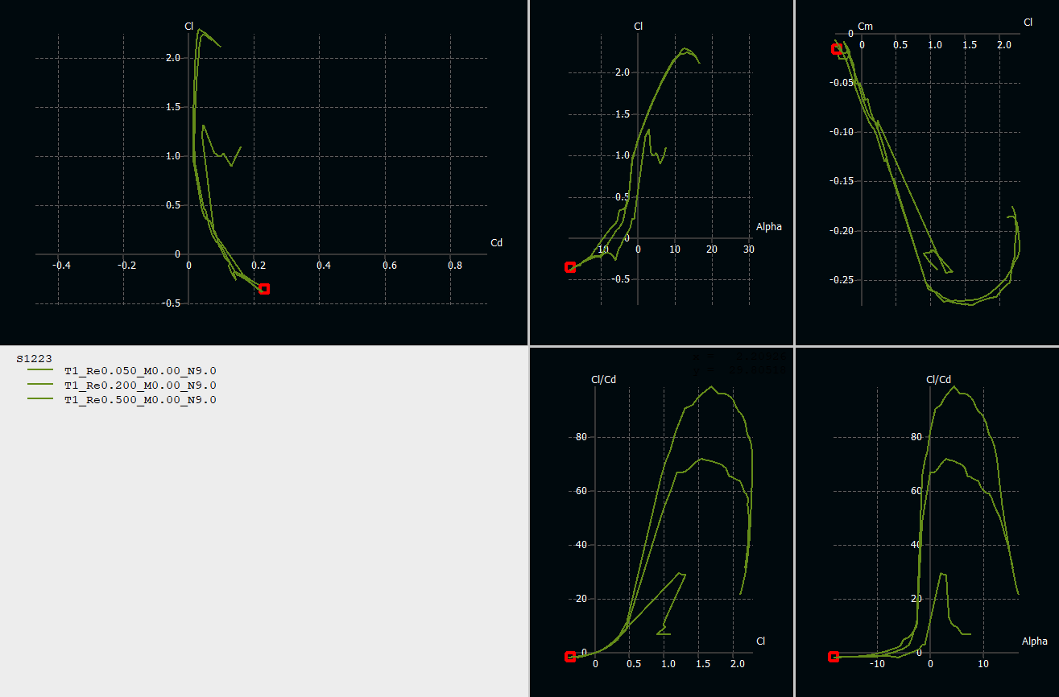

**B — E205 (medium low-Re, balanced low-Re performance)**

**Typical character**

* Designed for low-Re but smoother stall and better robustness than extreme high-lift foils. Moderate CL-max, predictable behavior, decent L/D plateau.

**Re = 50,000**

1. **Drag polar:**
   * Moderate drag; not as low as laminar mid-Re foils but smoother polar with predictable drag rise.
2. **Lift curve:**
   * Reasonable slope; CL-max​ lower than S1223 but stall smoother.
3. **Cm:**
   * Small to moderate negative Cm; stable behavior.
4. **L/D vs Cl:**
   * Peak L/D lower than S1223 at very low Re, but broader (more forgiving).
5. **L/D vs α:**
   * Broad, forgiving plateau — efficient across a wider α band.

**Bottom line at Re=50k:** E205 is more forgiving and easier to handle than S1223, but requires longer runway than S1223 for the same weight/wing area. Good for small UAVs that need robustness.

**Re = 200,000**

1. **Drag polar:**
   * Noticeable improvement; drag at cruise Cl lowers and polar smoothens.
2. **Lift curve:**
   * Clean linear region, decent CL-max​ (1.0–1.3 depending on flap). Gentle stall.
3. **Cm:**
   * Stable, small variations to easy trim.
4. **L/D:**
   * Peak L/D is solid and broad — good cruise and climb tradeoffs.
5. **L/D vs α:**
   * Very usable plateau; good off-design performance.

**Bottom line at Re=200k:** E205 is a robust, predictable choice for small HTOL aircraft where handling and contamination tolerance matter.

**Re = 500,000**

1. **Drag polar:**
   * Further improved. At 500k E205 acts very well—low drag at cruise Cl and predictable stall drag rise.
2. **Lift curve / Cm / L/D:**
   * All continue to be favorable. L/D peak may be comparable to NACA 23012 in some ranges, while still offering gentler stall.

**Bottom line at Re=500k:** E205 is a strong all-rounder: good efficiency, forgiving stall, and low trim penalty — excellent if range and handling both matter.

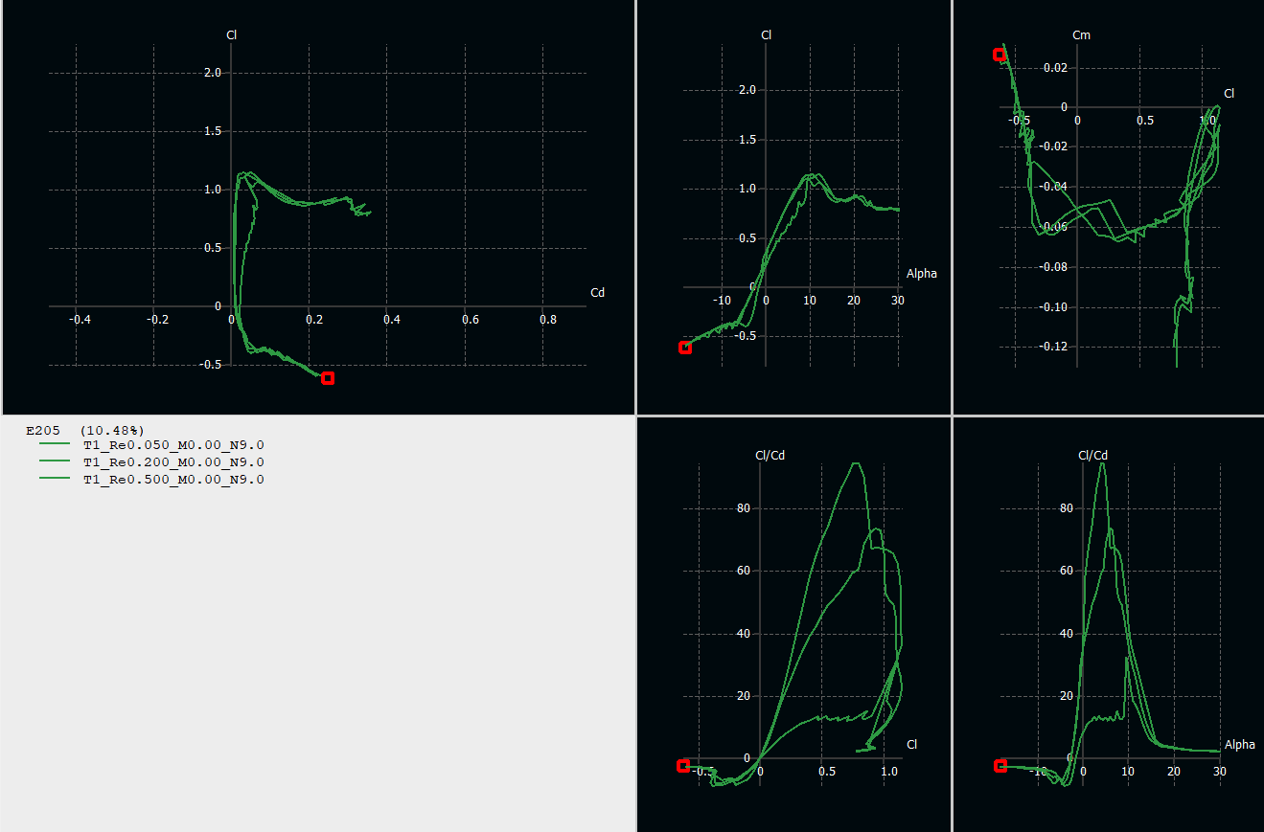

**C — NACA 23012 (classic general-aviation section)**

**Typical character**

* Classic compromise: reasonable CL-max​, predictable/stable stall, moderate Cm. Works well across mid Re; not optimized for extreme low Re laminar performance but robust.

**Re = 50,000**

1. **Drag polar:**
   * Rather poor at very low Re vs dedicated low-Re foils — drag higher at cruise Cl, polar shows moderate Cd.
2. **Lift curve:**
   * Smoother slope and gentler stall than S1223; CL-max​ probably lower than S1223 and maybe similar or a bit greater than E205 at 50k.
3. **Cm:**
   * Moderate negative Cm, but predictable.
4. **L/D:**
   * Peak L/D lower at 50k (classic sections were not designed for 50k).
5. **L/D vs α:**
   * Plateau exists but is lower and possibly narrower.

**Bottom line at Re=50k:** NACA 23012 is not ideal for very small, very low-Re HTOL vehicles pick a low-Re specialized foil instead.

**Re = 200,000**

1. **Drag polar:**
   * Much better drag at cruise Cl drops and polar becomes typical GA-like.
2. **Lift curve:**
   * Good linear behavior, CL-max​ decent (1.3–1.5 with flaps).
3. **Cm:**
   * Manageable; tail sizing straightforward.
4. **L/D:**
   * Competitive peak L/D and broad plateau - good cruise and approach performance.
5. **L/D vs α:**
   * Broad and forgiving.

**Bottom line at Re=200k:** NACA 23012 becomes a very attractive candidate for HTOL - balanced lift, good efficiency and excellent handling.

**Re = 500,000**

1. **Drag polar:**
   * Excellent NACA 23012 shows its classic performance at this Re: low drag at cruise Cl and predictable behavior.
2. **Lift curve :**
   * Strong, well-behaved characteristics: good CL-max​ with flaps, benign stall, modest negative Cm. L/D peak is high and broad enough for practical cruise.
3. **Cm:**
   * Cm remains modestly negative and stable through the linear lift range, implying predictable trim and minimal control input changes through varying flight phases.
4. **L/D:**

* Linear up to stall, with a gentle drop post-stall, making the aircraft forgiving and easy to recover.

1. **L/D vs α:**

* Wide plateau of high efficiency, meaning the wing can operate efficiently across a range of speeds and weights without significant drag penalties.

**Bottom line at Re=500k:** NACA 23012 is an excellent, conservative choice for HTOL where you want a reliable balance between takeoff/landing capability and cruise efficiency.

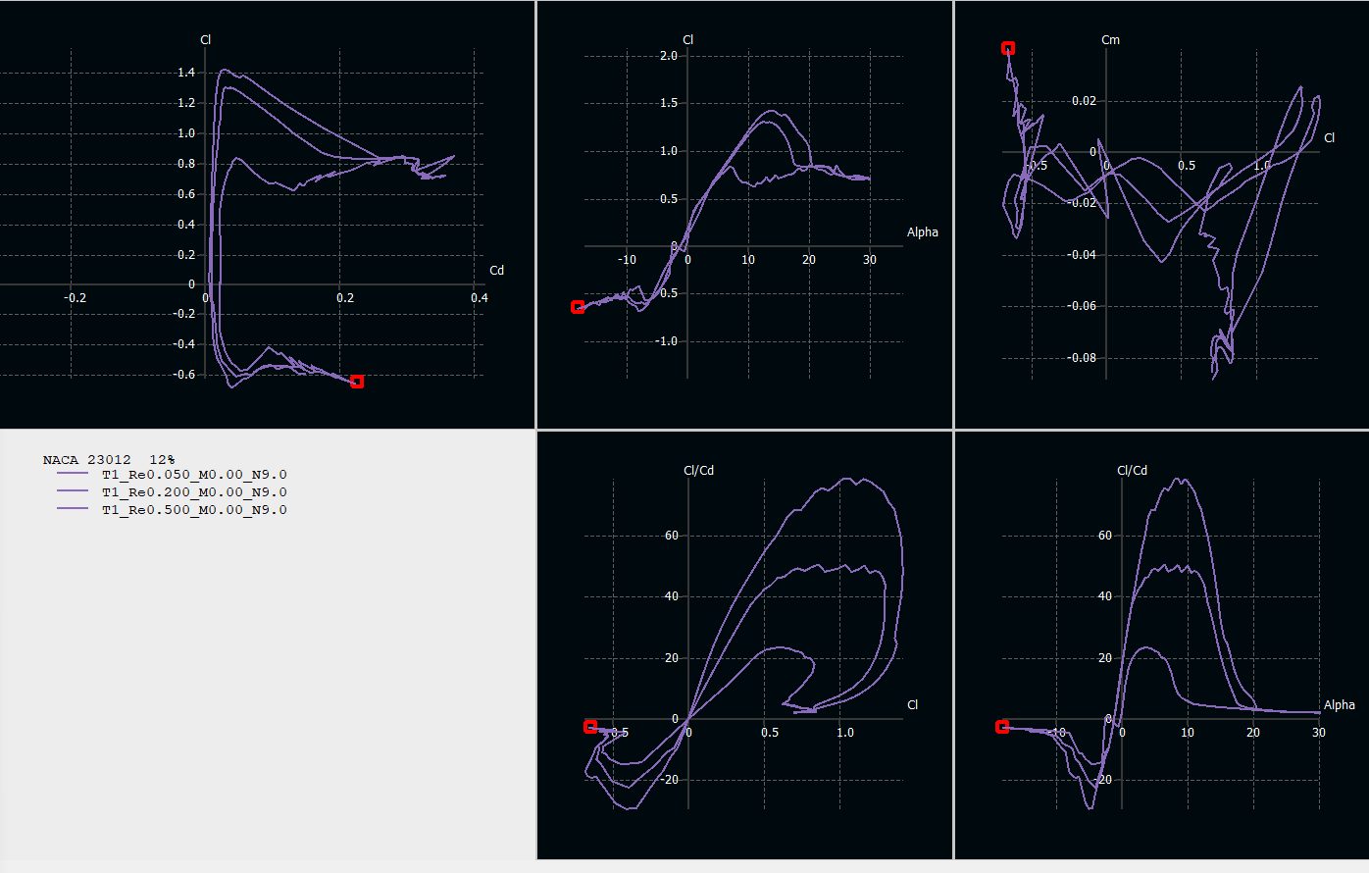

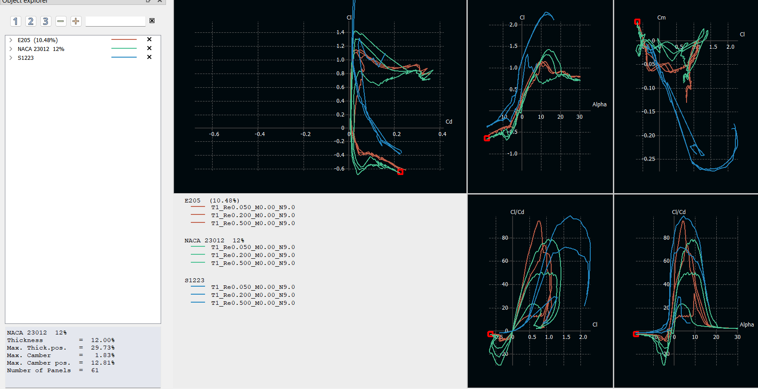

**Conclusion**

For HTOL aircraft, where efficiency across a wide angle of attack, smooth stall behavior, and low cruise drag are essential, the **NACA 23012** airfoil is the best overall choice. It consistently offers a strong lift-to-drag ratio, predictable handling, and stable performance across all tested Reynolds numbers (50,000, 200,000, and 500,000) at Mach 0.

At **Re = 50,000** (micro UAVs / very low-speed HTOL), the **S1223** achieves the highest maximum lift and is ideal for extremely short take-off and landing operations, but it requires precise trim and is more sensitive to surface roughness. For a more forgiving and stable option at this Reynolds number, the **Eppler 205 (E205)** is preferable.

At **Re = 200,000** (small UAVs, ultralights), both the **NACA 23012** and **E205** are strong candidates. The NACA 23012 provides a good balance between maximum lift and cruise efficiency, while the E205 offers smoother low-Reynolds-number behavior and a gentler stall. The S1223 should only be used here if maximum STOL performance is the top priority.

At **Re = 500,000** (larger UAVs, light aircraft), the **NACA 23012** clearly outperforms the others, combining high lift-to-drag ratios, predictable stall, and easy trimming. The E205 remains a workable alternative, while the S1223 becomes less attractive due to reduced performance advantages and persistent trim penalties.

Overall, the **NACA 23012** is the most versatile and efficient airfoil for HTOL aircraft, with the **E205** being a reliable second choice for smoother handling at lower Reynolds numbers, and the **S1223** serving as a niche option for specialized ultra-low-speed STOL missions.